Pokhara University

Level: Bachelor | Semester – Spring | Year : 2006
Programme: BE |  | Full Marks: 100
Course: Engineering Mathematics II |  | Time : 3hrs.

Candidates are required to give their answers in their own words as far as practicable.
The figures in the margin indicate full marks.

Attempt all the questions.

 | - Obtain the equation of the plane which passes through the point (-1, 3, 2) and is perpendicular to each of two planes. x + 2y + 2z = 5 and 3x + 3y + 2z = 8.  OR  Find the length and equation of the shortest distance between the lines 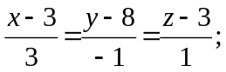 2x – 3y + 27 = 0, 2y – z +20 = 0  - Find the equation of tangent planes to the sphere x² + y² + z² – 4x + 2y – 6z + 5 = 0 which are parallel to the plane 2x + y – z = 0 | 7  8
 | - What are the criteria of a function of two independent variables to have extreme values? Find the extreme value of x² + y² + z² when 1/x + 1/y +1/z = 1.  - Define partial derivative of a function at a point. If 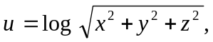show that:  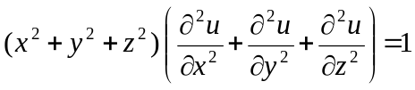 | 8  7
 | - Sketch the region of integration and evaluate by interchanging the order of integration 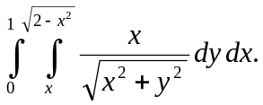  - Find the volume of the solid whose base is the region in xy-plane that is bounded by the parabola y = 4 – x² and the line y = 3x, while the top of the solid is bounded by the plane z – x = 4. | 7  8
 | - Define the first order linear differential equations with suitable example and solve: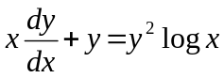.  - Solve 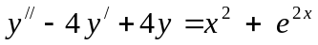  OR  Solve by the method of variation of parameters y // + y = secx | 7  8
 | - Solve by power series method y // + y = 0.  OR  Define Bessel equation and its solution. Show that 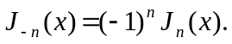  - Solve the initial value problem. | 8  7
 | - Find the Laplace transform of t² sin2t  - Find the inverse Laplace transform of 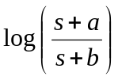  - If 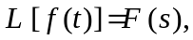 then show that 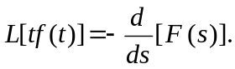 Using it evaluate L[t² cos 3t].  OR  Solve the initial value problem  by using Laplace transform. | 4  4  7
 | Attempt the following:  - Find the angle between the planes 2x + 3y – z = 12 and x +2y – z = 14.  - Find integrating factor of 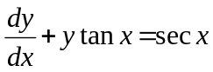  - Write down the condition that the cone ax² + by² + cz² + 2fyz + 2gzx + 2hxy = 0 may have set of three mutually perpendicular generators.  - Find the Laplace transform of t sinat.  - If v = x³ + y³ + z³ than verify that 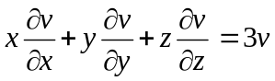 | 2×5

